|  |  |
| --- | --- |
| *Pacific Gas and Electric Company* | |
| Release 9.6.1 Installation Guide | |
|  |  |
|  |  |
| Project | ED AM/GIS |
|  |  |
| Prepared by | Subhankar Baidya |
| Date | 06/5/2015 |
| Version | 1.0 |
| Version Type | Final |

|  |  |  |  |
| --- | --- | --- | --- |
| Revision History | | | |
| Document # | Date | Author | Summary of Changes |
| 1.0 | 06/05/2015 | Subhankar Baidya | Initial Document Creation |

# Introduction

## Purpose

This document is intended to detail the implementation and configuration steps required to implement Release 9.6.2 Installation Guide. This document describes the various configuration aspects required to complete any manual or automatic patch associated with this release. Each section in this document contains the steps required to patch the system in production.

## Terms Used

|  |  |
| --- | --- |
| OOTB | Out of the box. Unmodified from the commercial version. |
| TFS | Team Foundation Server |

## External Documents

Referenced are any external configuration documents or exports. These are documents that contain more detailed information about configuring a system or documents that can be loaded into an application to perform the configuration detailed in this document.

## List Of Fixes

Below is the list of change requests detailing all fixes for the data model for this release:

|  |  |
| --- | --- |
| **Item Number** | **Title** |
| 22081 | Master TFS DM9.6.2 |
| 22080 | DM 9.6.2 - Unselect the checkbox on the CGC, Default (operating number) and loadbreak annotation classes of Transformer Anno |
| 22082 | DM 9.6.2 - Unselect the checkbox on the CCRating annotation class of SwitchAnno |
|  |  |
|  |  |
|  |  |
|  |  |
|  |  |
|  |  |
|  |  |
|  |  |
|  |  |
|  |  |

## Summary of Steps to Complete Install

Contents

1 Introduction 3

1.1 Purpose 3

1.2 Terms Used 3

1.3 External Documents 3

1.4 List Of Fixes 4

1.5 Summary of Steps to Complete Install 4

2 Open a Database Connection in ArcCatalog 6

3 22080 DM 9.6.2 - Unselect the checkbox on the CGC, Default (operating number) and loadbreak annotation classes of TransformerAnno 7

4 22082 – DM 9.6.2 - Unselect the checkbox on the CCRating annotation class of SwitchAnno 11

5 Update Data Model Version Table 13

6 Known Issues 14

# Open a Database Connection in ArcCatalog

1. Open ArcCatalog.
2. Within the Catalog Tree, expand “Database Connections” and open the active connection for this process. This is the connection that is referenced in the change request associated with this document (EDGIS<DB name in the format X#Y> )

# 22080 DM 9.6.2 - Unselect the checkbox on the CGC, Default (operating number) and loadbreak annotation classes of TransformerAnno

1. Expand the Electric Dataset
2. Navigate to TransformerAnno, complete below steps:

EDGIS.TransformerAnno

* 1. Right click **TransformerAnno** and choose the properties option

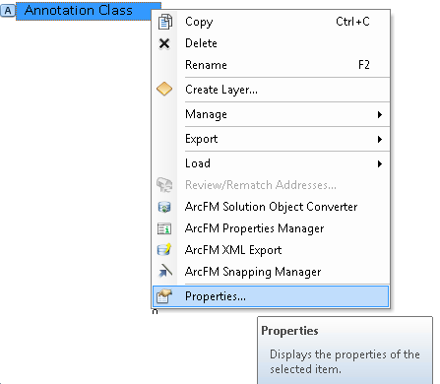

* 1. Select the "Annotation Classes" Tab



* 1. Select the "CGC" Annotation Class
  2. Click the expression button



* 1. Select the Maplex tab



* 1. Uncheck the option for "Remove extra spaces from label".
  2. Make sure that the "Remove extra line breaks from label" is also unchecked (This is by default).

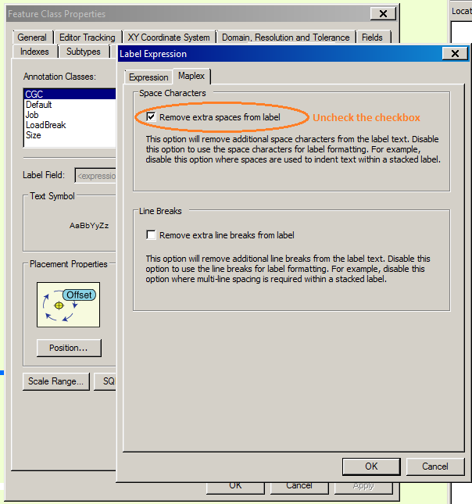

* 1. Click OK to click the Expressions Dialog
  2. Click OK to set these properties and close the Properties Dialog
  3. Repeat the above steps for **Default** and **LoadBreak** annotation classes

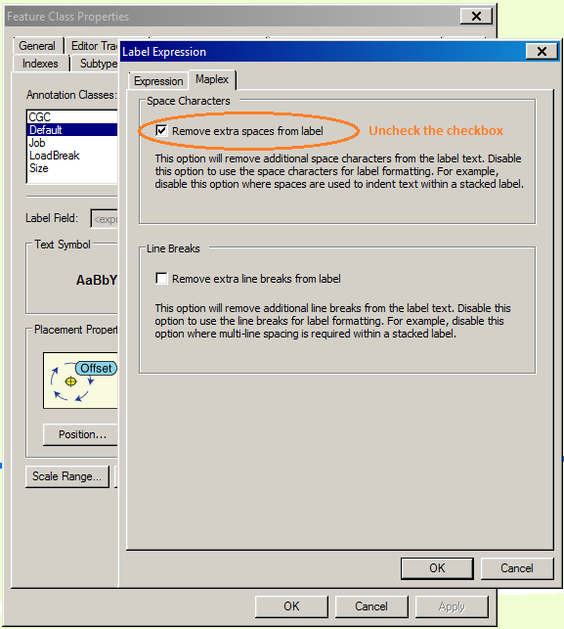



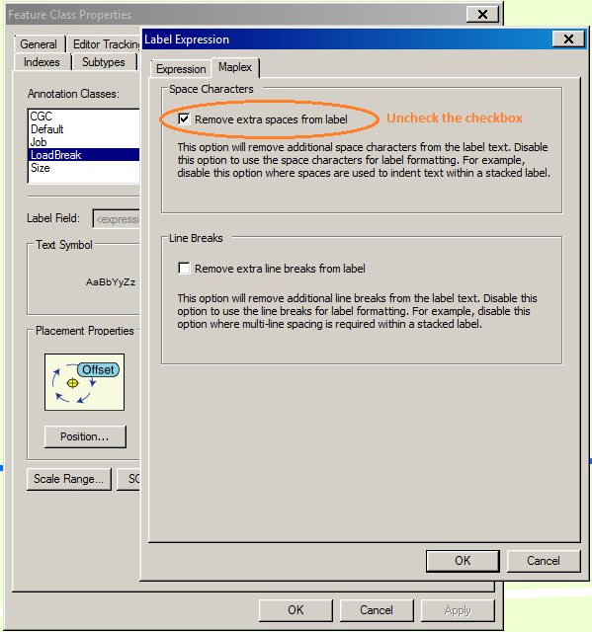

# 22082 – DM 9.6.2 - Unselect the checkbox on the CCRating annotation class of SwitchAnno

1. Expand the Electric Dataset
2. Navigate to TransformerAnno, complete below steps:

EDGIS.SwitchAnno

* 1. Right click **SwitchAnno** and choose the properties option



* 1. Select the "Annotation Classes" Tab



* 1. Select the "CCRating" Annotation Class
  2. Click the expression button



* 1. Select the Maplex tab



* 1. Uncheck the option for "Remove extra spaces from label".
  2. Make sure that the "Remove extra line breaks from label" is also unchecked (This is by default).

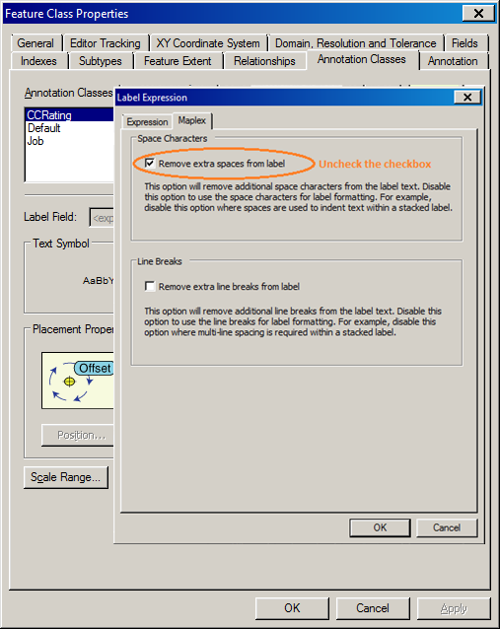

* 1. Click OK to click the Expressions Dialog
  2. Click OK to set these properties and close the Properties Dialog

# Update Data Model Version Table

**Database Configuration:**

1. Open SQL Plus.
2. Log in using the same server and user as was used in section 2.  
     
   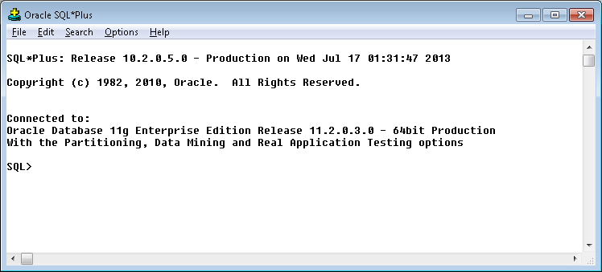
3. Run the SQL below:

update pgedatamodelversion set currentidc='N' where currentidc='Y';

insert into pgedatamodelversion (OBJECTID, CURRENTIDC, DATEAPPLIED, APPLIEDBYPERSONNAME, MODELVERSION) values (**INSERT NEXT VALID ID**,'Y',sysdate,'**<INSERT TEAM MEMBER DONE BY>**','**<INSERT DM VERSION>** GOLD **CR<INSERT CR NUMBER>**');

commit;

# Known Issues

<Please List any other issues encountered here while following the document>